The vitamins are classified into
- Fat soluble vitamins: A, D, E and K
2. Water soluble vitamins: * vitamin B complex
* vitamin C.
Points of differences | Fat-soluble vitamins | Water-soluble vitamins
Solubility in fat | Soluble | Insoluble
Water solubility | Insoluble | Soluble
Absorption | Along with lipids; requires bile salts | Simple absorption
Carrier protein | Present | *No carrier proteins
Storage | Stored in the liver | *No storage
Urinary excretion | Not excreted | Excreted
Deficiency | Manifests only when stores are depleted | Manifested rapidly as there is no storage
Toxicity | Hypervitaminosis may results | Unlikely,
Treatment of deficiency | large doses may prevent deficiency | Regular dietary supply is required
Major vitamins | A, D, E and K | B-complex and C

provitamins
are vitamin precursors
Vitamin precursors Vitamins

Vitamin A ( anti-night blindness, anti- xeropthalmic vitamin)
Provitamin: Carotenoids
- including (Beta-carotene, α-carotene, ɣ-carotene and cryptoxanthine)
- present in plants as Yellow/orange/red fruits and vegetables (AS Carrots, apricots, cantaloupe, mangos, sweet potato) & dark green leafy vegetables
Beta carotene has two beta ionone rings connected by a polyprenoid chain
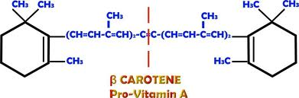
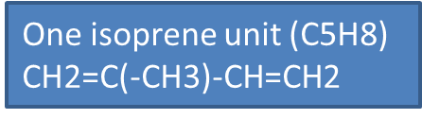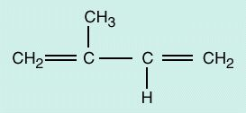
- One molecule of β-carotene can give rise to two molecules of vitamin A
as it contain 2 β-ionone rings and symmetric
- One molecule of any of the other carotenoids can give rise to only one molecule of vitamin A as they are asymetric
Vitamin A: present only in animal tissues. So, sources of vitamin A are animal sources as liver , milk, egg yolk, butter, fish, and cod liver oil
- Compounds with vitamin A activity (Retinoids)
include
1- Retinol (vitamin A alcohol)
2- Retinal (vitamin A aldehyde)
3- Retinoic acid (vitamin A acid).
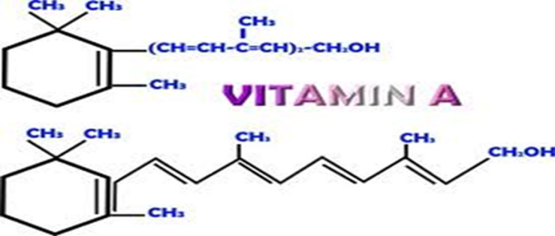
Retinol is the parent substance of the retinoids, which include retinal and retinoic acid. The retinoids also can be synthesized from the provitamin.
- Absorption, storage, transport and uptake of vitamin A by the tissues
- Retinyl esters and carotenoids are obtained from food. Retinyl esters and β- carotenes are absorbed with lipids , incorporated into chylomicrons, → lymphatic channels→blood .
- Vitamin A is stored in liver (stellate cells) as retinyl esters (Retinol palmitate) . If needed by body, Retinyl esters are converted to retinol to bind with retinol binding protein(RBP) in the blood as transretinol to to be transported to peripheral tissues .
- Uptake by Tissues:The retinol-RBP complex binds to specific receptors on the retina, skin, gonads and other tissues. The RBP does not enter in the cell. Once retinol has been taken up by a cell, it can be oxidized to retinal by retinol dehydrogenase ( reversible reaction; retinal may be reduced to retinol by retinal reductase which is the same enzyme). Retinal can be oxidized to retinoic acid which cannot be converted back to the other forms (Irreversible reaction). Retinoic acid plays an important role in gene transcription (Act as steroid hormone). Retinoic acid regulates gene transcription by binding to nuclear receptors known as retinoic acid receptors (RARs) which are bound to hormone responsive elements (HRE) of DNA. Thus, genes are activated
- ------------- ----------------
Diet
β- Carotene
O2
Β-carotene dioxygenase in intestine
Retinyl esters
Retinal
NADPH+H⁺
Retinal reductase in intestine
NADP
Absorbed with chylomicrons to Blood then hepatocyte in liver to be transformed to retinol which enters the stellate cells(fat cells in liver ) to be stored as retinol palmitate which when needed, is converted to retinol and released in the blood bound to RBP to reach tissues where retinol enter cells
Retinol
Retinol - CH2OH
NADP
Retinol dehydrogenase in tissues
Role in night vision
Retinal - CHO
NADPH+H⁺

Aldehyde dehydrogenase(O)
((
Retinoic acid bind to nuclear receptors known as retinoic acid receptors (RARs) and finally to HRE of DNA → activate genes → action

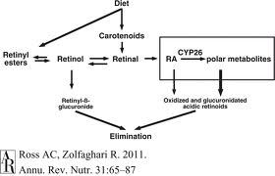 acid
Retinoic acid - COOH
acid

- Functions:
- Eye: Retinal is a component of the retinal pigment (Rhodopsin;also called the visual purple) which is essential for vision in dim light.
2. Retinol acts like a steroid hormone in controlling the expression of certain genes. (LOOK ABOVE)
3- Reproductive system : Retinol is necessary for normal reproduction (Sperm production {spermatogenesis} Fetal development in females , and Sexual maturation). This may be because retinol is needed for local synthesis of retinoic acid from retinol in testis and embryos
4-Vitamin A is necessary for the maintenance of normal epithelium and skin:.
Vitamin A, and more specifically, retinoic acid, appears to maintain normal skin health by switching on genes and differentiating keratinocytes (immature skin cells) into mature epidermal cells. Also retinoic acid is important for glycoprotein synthesis
5. Anti-oxidant property: There is a correlation between the occurrence of epithelial cancers and vitamin A deficiency. The anticancer activity has been attributed to the natural anti-oxidant property of carotenoids.
6. Beta carotenes may be useful in preventing heart attacks.
7.Vitamin A is necessary for normal construction of bone and teeth.
- Deficiency Manifestations:
I. Eyes:
1- Night Blindness or Nyctalopia: Visual acuity is diminished in dim light.
2- Xerophthalmia: The conjunctiva and cornea become dry, thick and wrinkled; due to keratinization of epithelium Of lacrimal duct, so no lacrimal secretion.
3- Bitot's Spots: Greyish-white triangular plaques firmly adherent to the conjunctiva.
4- Keratomalacia: Softening and fissuring of the cornea.
II. Skin and Mucous Membrane Lesions
1- Follicular hyperkeratosis: The skin becomes rough. Epithelium is atrophied Keratinisation of urinary tract epithelium may lead to urinary calculi.
2- Increased occurrence of generalised infections.
Hypervitaminosjs A or Toxicity:
Excessive intake can lead to toxicity since the vitamin is stored.
Symptoms : anorexia, irritability, headache, peeling of skin, drowsiness and vomiting. Some of these signs are due to increased intra-cranial tension. Higher concentration of retinol releases lysosomal enzymes, leading to cellular death.

(N.B): Isoretinone, a synthetic variant of vitamin A is known to reduce the sebaceous secretions, hence it is used to prevent acne formation during adolescence.

Vitamin D (CHOLECALCIFEROL)
There are 2 types of naturally occuring vitamin D :
Nature of provitamin (source) | Provitamin | Vitamin
Plant sterol | Ergosterol | vitamin D2 (ergocalciferol)
Animal sterol | 7-dehydrocholesterol | vitamin D3 (cholecalciferol).

Both vitamins are of equal potency, but the intestinal absorption of provitamin ergosterol is poor making it not an important source of vitamin D
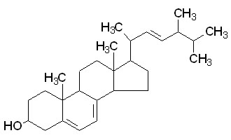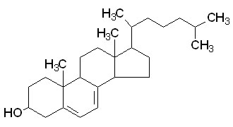
Ergosterol | 7- DehydroDehydrocholesterol
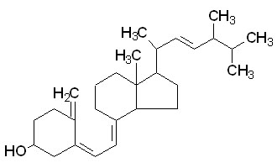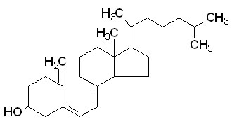
VitaminD₂ | Vitamin D₃
Ergosterol differ from 7-dehydrocholesterol only in its side chain, which is unsaturated and contain an extra methyl group.
Ultraviolet irradiation cleaves the B ring of both compounds.
- Vitamin D2 is produced from ergosterol in the plants on exposure to the sunlight . Ergocalciferol (vitamin D2) may be made commercially from plants in this way
- In animals cholecalciferol (Vitamin D3) is formed from 7-dehydrocholesterol in exposed skin.
Metabolism and actions of vitamin D

Vitamin D3 in animal food
UV rays
7 dehydrocholesterol in skinl
-promote bone formation
-Also promotes bone resorption
Thereby promoting normal bone and mineral physiology

Activation In liver by hepatic microsomal enz 25 α- hydroxylase
Vitamin D3 (Cholecalciferol)
25 - hydroxycholecalciferol
Activation In kidney by mitochondrial 1 α- hydroxylase
1,25 dihydroxycholecalciferol (Calcitriol) (Active form of the vitamin)
Increase renal rubular reabsorption of calcium and phosphorous
Another metabolite of vitamin D (24,25 dihydroxycholecalciferol ) may help in this action
renal tubules
Bone
Increase absorption of calcium and phosphorus from the intestine
Intestinal mucosal cells

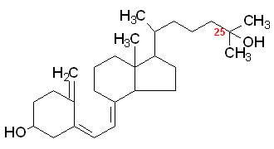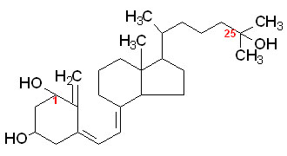
25-hydroxyvitamin D₃ | 1,25-dihydroxyvitamin D₃

Mechanism of action of Calcitriol: For oral exam.(reading)
- Calcitriol acts like a steroid hormone. It enters the cell and binds to a nuclear receptor (VDR) leading to regulating the expression of genes (whose promoters contain specific DNA sequences known as vitamin D response elements (VDREs)) which mediate its biologic activity e.g. stimulate expression of genes AS the gene that code for calcium binding protein (Calbindin)→ ↑absorption of calcium in the intestine. Phosphate absorption occurs secondary to the absorption of calcium.
Most if not all effects of Calcitriol are mediated by VDR
- In addition to regulating gene expression, some actions of 1,25(OH)2D are more immediate, and may be mediated by a membrane bound vitamin D receptor that has been less well characterized than the nuclear VDR. Calcitriol has a number of non genomic actions including the ability to stimulate calcium transport across the plasma membrane. It regulate calcium and chloride channel activity, protein kinase C activation and distribution, and phospholipase C activity in a number of cells including osteoblasts, liver, muscle , and intestine . These rapid effects of 1,25(OH)2D have been most extensively studied in the intestine.
- So, 1,25(OH)2D regulates transcellular calcium transport using a combination of genomic and nongenomic actions.

Deficiency:
- Rickets in children : characterized by - Softening and deformities of bones
- Delayed teething, standing and walking.
- Low serum calcium and phosphorus With
high alkaline phosphatase level.

- Osteomalacia in adults. bone deformities and low serum calcium and phosphorus.

Hypervitaminosis D
- Due to : prolonged intake of large amounts of vitamin D
- Symptoms: weakness, polyuria, intense thirst, difficulty in speaking. Late symptoms are; abnormal deposition of calcium and phosphate in tissues as lungs, kidneys together with a loss in weight.

Vitamin E

- α-tocopherol = 5,7,8 trimethyl tocol. It has the highest power than the other vitamers
- Other naturally occuring vitamers include: β,ɣ, δ tocopherol
Functions
1- Vitamin E is the most powerful natural anti-oxidant
- It is the lipid phase antioxidant.
- It protects RBC from hemolysis. By preventing the peroxidation so it keeps the structural and functional integrity of all cells.
- Protect vitamin A and carotenoids from oxidative destruction of free radicals
- Gradual deterioration of ageing process is due to the cumulative effects of free radicals.
- It reduces the risk of atherosclerosis by reducing oxidation of lDL .
2- Vitamin E boosts immune response.
3- It acts as a co factor in electron transfer system of mitochondria.
4- Important for fertility in some animal species
Vitamin K
Functions
1. Vitamin K is necessary for synthesis of blood clotting factors II, VII, IX and X in the liver.
Vitamin K is a cofactor for carboxylase enzyme that lead to gamma carboxylation of glutamic acid residues of these blood clotting factors.
ɣ- Carboxylated glutamate residues are the binding sites for calcium which is essential for blood clotting .
- Vitamin K is involved in electron transport and oxidative phosphorylation in mitochondria so is important for ATP formation
DEFICIENCY
- -Diatery deficiency seldom occurs since the intestinal bacterial synthesis is sufficient to meet the needs of the body.
- Prolonged antibiotic therapy and gastrointestinal infections with diarrhea will destroy the bacterial flora →vitamin K deficiency.
- Manifestations: -Bleeding tendency
Hypervitaminosis K
Occurs in newborn infants, if they receive high doses of vitamin K. Hemolytic jaundice occurs due to increased catabolism of Hb in the blood clots.

